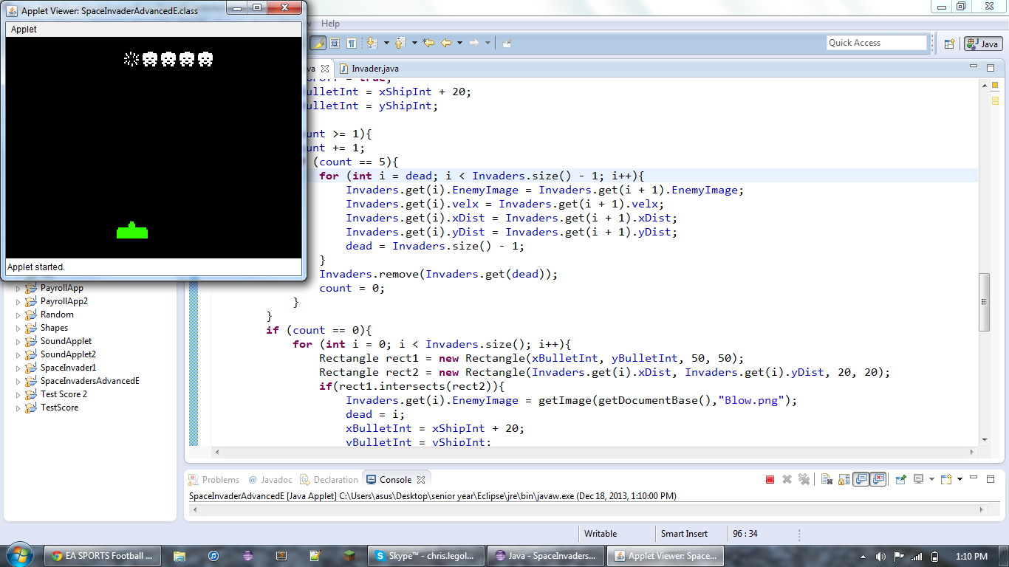

//Programmer Chris Richey

//date: 12/16

//Calculates: SpaceInvader

import java.applet.\*;

import javax.swing.\*;

import javax.swing.Timer;

import java.awt.\*;

import java.util.\*;

import java.awt.event.\*;

import java.text.\*;

public class SpaceInvaderAdvancedE extends JApplet implements KeyListener, ActionListener{

JPanel pnlMain = new JPanel();

Image shipImage;

Image bulletImage;

int xEnemyInt = 10;

int yEnemyInt = 10;

int xCEnemyInt = 10;

int xShipInt = 50;

int yShipInt = 250;

int xBulletInt = 70;

int yBulletInt = 250;

int count = 0;

int dead = 0;

boolean OnorOff = true;

boolean EnemyChange = true;

Timer myTimer = new Timer(250,this);

ArrayList<Invader> Invaders = new ArrayList<Invader>();

public void init(){

myTimer.start();

shipImage = getImage(getDocumentBase(),"ship.png");

bulletImage = getImage(getDocumentBase(),"bullet.png");

for (int i = 0; i < 5; i++){

Invaders.add(new Invader());

}

setContentPane(pnlMain);

this.getContentPane().setBackground (Color.BLACK);

resize(400,300);

addKeyListener(this);

setFocusable(true);

}

public void actionPerformed(ActionEvent evt) {

//count tells if enemy is dead

//0 = alive

//>0 = dead

//once shot count goes to 1 then goes up every time the actionPreformed is run

//at five they enemy goes black

requestFocus();

//enemy stuff

//sets pics

for (int i = 0; i < Invaders.size(); i++){

if (count == 0){

Invaders.get(i).EnemyImage = getImage(getDocumentBase(),"Emeny1 (1).png");

}

}

//movement

if(Invaders.size() > 0){

if(Invaders.get(0).xDist > getWidth() - (Invaders.size() \* 25) - 10){

Invaders.get(0).velx = -10;

Invaders.get(0).yDist += 10;

}

if(Invaders.get(0).xDist < 10){

Invaders.get(0).velx = 10;

Invaders.get(0).yDist += 10;

}

if (count == 0){

Invaders.get(0).xDist += Invaders.get(0).velx;

}

Invaders.get(0).setInvader(Invaders.get(0).xDist, Invaders.get(0).yDist, Invaders.get(0).velx);

for(int x = 1; x < Invaders.size(); x++){

Invaders.get(x).setInvader((Invaders.get(x-1).xDist + 25), (Invaders.get(x-1).yDist), (Invaders.get(x-1).velx));

}

}

repaint();

//shot bullet and collision code

if (!OnorOff){

yBulletInt -= 10;

}

if (yBulletInt <= 0){

OnorOff = true;

xBulletInt = xShipInt + 20;

yBulletInt = yShipInt;

}

if (count >= 1){

count += 1;

if (count == 5){

for (int i = dead; i < Invaders.size() - 1; i++){

Invaders.get(i).EnemyImage = Invaders.get(i + 1).EnemyImage;

Invaders.get(i).velx = Invaders.get(i + 1).velx;

Invaders.get(i).xDist = Invaders.get(i + 1).xDist;

Invaders.get(i).yDist = Invaders.get(i + 1).yDist;

dead = Invaders.size() - 1;

}

Invaders.remove(Invaders.get(dead));

count = 0;

}

}

if (count == 0){

for (int i = 0; i < Invaders.size(); i++){

Rectangle rect1 = new Rectangle(xBulletInt, yBulletInt, 50, 50);

Rectangle rect2 = new Rectangle(Invaders.get(i).xDist, Invaders.get(i).yDist, 20, 20);

if(rect1.intersects(rect2)){

Invaders.get(i).EnemyImage = getImage(getDocumentBase(),"Blow.png");

dead = i;

xBulletInt = xShipInt + 20;

yBulletInt = yShipInt;

OnorOff = true;

count = 1;

}

}

}

}

public void keyPressed(KeyEvent e) {

int key = e.getKeyCode();

if (key == 37){

xShipInt -= 10;

if (OnorOff){

xBulletInt = xShipInt + 20;

yBulletInt = yShipInt;

}

}

else if (key == 39){

xShipInt += 10;

if (OnorOff){

xBulletInt = xShipInt + 20;

yBulletInt = yShipInt;

}

}

else if (key == 32){

OnorOff = false;

}

repaint();

}

public void keyReleased(KeyEvent e) {

}

public void keyTyped(KeyEvent e) {

}

public void paint(Graphics g){

super.paint(g);

for (int i = 0; i < Invaders.size(); i++) {

g.drawImage(Invaders.get(i).EnemyImage, Invaders.get(i).xDist, Invaders.get(i).yDist, 20, 20, this);

}

g.drawImage(shipImage,xShipInt, yShipInt,this);

g.drawImage(bulletImage,xBulletInt, yBulletInt,this);

}

public void Update(Graphics gr) {

paint(gr);

}

}

import java.awt.Image;

public class Invader{

int xDist = 10;

int yDist = 10;

int velx = 10;

Image EnemyImage;

public void setInvader(int x, int y, int Vx){

xDist = x;

yDist = y;

velx = Vx;

}

}